

Eurogeographics

Quality Knowledge Exchange Network

Results on a Quality Questionnaire
October 2013

1. Background
In 2013 the EuroGeographics Quality Knowledge Exchange Network decided to run a questionnaire within its members to determine how quality was measured. The questionnaire was run on-line and the results are presented in this document. In total 12 organisations responded – these being from the countries shown below. There is no assessment of the results – they are purely factual and the reader can draw their own conclusions as to what these results mean.
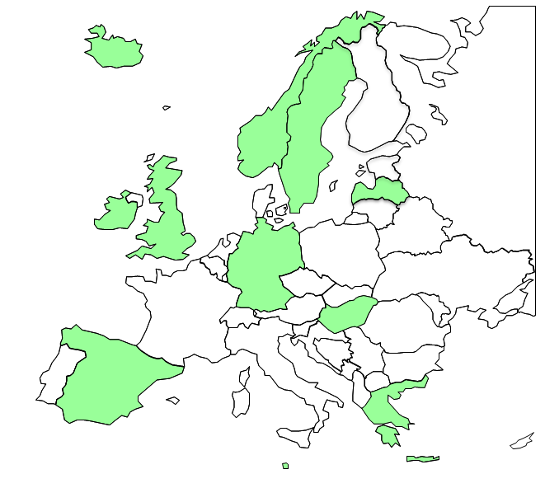

The results in this document were compiled by Jonathan Holmes (Ordnance Survey Great Britain) on behalf of the EuroGeographics Quality Knowledge Exchange Network.

2. Evaluation method
NB. Within the table below all of the results are shown as the number of positive responses to the question followed by the total possible number of responses.

What ISO data quality elements and sub elements are usually evaluated in data quality assessments and how do you measure them?

 | Full inspection | Sampling
Completeness – Commission | 3/12 | 4/12
Completeness - Omission | 3/12 | 6/12
Logical consistency - Conceptual  Consistency | 4/12 | 3/12
Logical consistency - Domain  consistency | 9/12 | 0/12
Logical consistency - Format  consistency | 8/12 | 0/12
Logical consistency - Topological  Consistency | 9/12 | 0/12
Positional accuracy - Absolute  Accuracy | 3/12 | 6/12
Positional accuracy - Relative  Accuracy | 1/12 | 5/12
Thematic accuracy - Classification  Correctness | 4/12 | 4/12
Thematic accuracy - Correctness  of quantitative attributes | 2/12 | 3/12
Thematic accuracy - Correctness  of non-quantitative attributes | 3/12 | 3/12
Temporal accuracy - Accuracy  of a time measurement | 1/12 | 1/12
Temporal accuracy - Temporal  Consistency | 2/12 | 0/12
Temporal accuracy - Temporal  validity | 1/12 | 0/12

3. Reference datum
NB. Within the table below all of the results are shown as the number of positive responses to the question followed by the total possible number of responses.

What reference datum do you use when assessing quality? (Note it was possible to tick more than one)

 | Ground Truth | Imagery | Independent Dataset | Other
Completeness – Commission | 4/12 | 6/12 | 2/12 | 2/12
Completeness - Omission | 3/12 | 5/12 | 1/12 | 1/12
Positional accuracy - Absolute  Accuracy | 6/12 | 2/12 | 0/12 | 0/12
Positional accuracy - Relative  Accuracy | 5/12 | 2/12 | 1/12 | 0/12
Thematic accuracy - Classification  Correctness | 3/12 | 5/12 | 2/12 | 1/12
Thematic accuracy - Correctness  of quantitative attributes | 2/12 | 2/12 | 3/12 | 0/12
Thematic accuracy - Correctness  of non-quantitative attributes | 2/12 | 1/12 | 3/12 | 0/12
Temporal accuracy - Accuracy  of a time measurement | 1/12 | 0/12 | 0/12 | 0/12
Temporal accuracy - Temporal  Consistency | 0/12 | 0/12 | 0/12 | 1/12
Temporal accuracy - Temporal  validity | 0/12 | 0/12 | 0/12 | 0/12

4. Methodology
NB. Within the table below all of the results are shown as the number of positive responses to the question followed by the total possible number of responses.

When assessing quality what method of assessment do you use? (Note it was possible to tick more than one)

 | Automatic | Semi-Automatic | Manual
Completeness – Commission | 1/12 | 3/12 | 6/12
Completeness - Omission | 1/12 | 2/12 | 5/12
Logical consistency - Conceptual  Consistency | 3/12 | 1/12 | 3/12
Logical consistency - Domain  consistency | 8/12 | 0/12 | 0/12
Logical consistency - Format  consistency | 7/12 | 0/12 | 0/12
Logical consistency - Topological  Consistency | 5/12 | 2/12 | 1/12
Positional accuracy - Absolute  Accuracy | 0/12 | 2/12 | 7/12
Positional accuracy - Relative  Accuracy | 0/12 | 0/12 | 5/12
Thematic accuracy - Classification  Correctness | 2/12 | 1/12 | 5/12
Thematic accuracy - Correctness  of quantitative attributes | 2/12 | 1/12 | 2/12
Thematic accuracy - Correctness  of non-quantitative attributes | 0/12 | 2/12 | 5/12
Temporal accuracy - Accuracy  of a time measurement | 0/12 | 1/12 | 1/12
Temporal accuracy - Temporal  Consistency | 1/12 | 1/12 | 0/12
Temporal accuracy - Temporal  validity | 0/12 | 1/12 | 0/12

5. How are data quality results presented internally?
Seven responses were received to this question.
The majority of these reported that they were using internal reports although this varied in frequency from every job to just once per year. One country made no formal presentation but used meetings and emails to report on the findings.

6. How are data quality results presented externally?
Four responses were received to this question.
The results varied from a single figure being reported, to an annual report on positional accuracy to recording conformance to the data specifications.

7. What data quality results are presented externally?

What data quality results are presented externally?

All results | Some Results | Aggregated Quality Results | Other | No results presented externally
0/12 | 2/12 | 2/12 | 2/12 | 4/12

8. Do you seek information from customer surveys concerning their understanding of quality metrics?
Nine response were received to this question – all of the responses stated that they didn’t seek information from customers concerning their understanding of quality metrics.

9. If yes to above, what are the results?
There were no responses to this section.

10. What level of engagement is there with your customers regarding data quality?
Seven responses were received to this question. The responses included:
- customers inform us if they encounter any quality issues
- we have user forums that meet regularly that can discuss these issues
- account managers will speak directly with customers if issues are identified.
11. How do you determine an acceptable conformance level for a dataset?
I.e. How do you determine what percentage of errors are acceptable? Do you for example, decide
yourselves, ask your customers, search for best practise or do something else?
Eight responses were received to this question with the majority deciding for themselves what the acceptable quality level should be. One country didn’t set any acceptable conformance levels but treated every issue as a possible non-conformance.

12. What are the scales of the datasets / products on which you carry out quality evaluation?
Eight responses were received to this question. The scales varied greatly from 1:1000 to 1:100,000 although the majority centred on the larger scales.

13. Do you measure the positional accuracy of objects in generalised / derived datasets?
Seven responses were received to this question with two organisations saying that they assess derived data and five stating that they didn’t.

14. If so, how do you evaluate and report it?
The two responses to this question stated that one of them tests the quality before it was generalised and the other uses a sampling based evaluation method using a set of control points. The results to the latter are presented internally and externally.

15. Do you measure any other elements / sub-elements for generalised / derived datasets?
Three organisations responded that they measure other elements or sub elements in derived datasets.

16. If so, what do you evaluate?
Topology was the main response from the three organisations that responded to this question.

17. How is data quality control managed within the production process?
NB. Within the table below all of the results are shown as the number of positive responses to the question followed by the total possible number of responses.

How is data quality control managed within the production process?

Through quality checks taken throughout the production process | Through quality checks taken after the production process | There are no quality checks carried out during production | Other (please specify)
3/12 | 2/12 | 0/12 | 3/12
The three organisations that responded “Other” explained that quality control was either built into the software or that they use both checks during and after the production process

18. If a dataset doesn’t meet the acceptable conformance level what action do you take?
Seven responses were received to this question with all of them stating that the work is sent back for re-work or that corrective action is taken if the data is already in the database.

19. Do you select features for sampling by area or by feature type?
Six responses were received to this question. Three stating by area and three stating that they used both methods.

20. If by area, what size area do you use?
Three organisations replied that they use a 1km x 1km area. One used a 12 hectare area and the other two stated that it varied depending on the size of the area being updated. There were six responses in total.

21. When sampling to measure the quality of a dataset what sampling strategy do you use?
NB. Within the table below all of the results are shown as the number of positive responses to the question followed by the total possible number of responses.

Sampling Strategy

Random | Semi Random | Stratified | Other (please specify)
2/12 | 1/12 | 2/12 | 2/12
The two organisations that responded “Other” explained that it was usually but not always semi-random or that they used a method of random and stratified.

22. Do you use any ISO standards to help determine the sampling strategy?
NB. Within the table below all of the results are shown as the number of positive responses to the question followed by the total possible number of responses.

ISO Standards

ISO 2859-1 | ISO 2859-2 | ISO 2859-3 | ISO 3951 | ISO 35342 | ISO 5725 | ISO 5479
0/12 | 3/12 | 1/12 | 1/12 | 0/12 | 0/12 | 0/12

23. When evaluating different sub elements (except the omission) do you use the same sample for assessing all the elements?
There were seven responses to this question with four saying that they used the same sample and three stating that they used a different sample.

